SUMMERVILLE CREDIT UNION · CONSOLIDATED MEMBER GUIDE · CSUM-26 of 30
Profile & Membership Management

Module: nFinia Digital Banking > Profile / Accounts & Memberships
Sources: Summerville Reports Series A (36 docs) + Series B (25 docs) | Features: nFinia Documentation Features Spreadsheet
01 PRODUCT SUMMARY

The Profile & Membership Management section allows members with multiple credit union memberships to switch the active membership context, manage account-level display settings, and access membership-specific configurations. Switching memberships changes all screens in the platform to show data for the newly selected membership.
The Accounts & Memberships view within More provides detailed settings for each account: custom nicknames, display order, visibility toggle, and account-specific configurations. Members can also view membership-level details such as membership number, account types, and linked services.
For members who have been designated as joint account holders on other memberships (such as a family member's account or a business account), the Profile screen is the access point for switching between those memberships without logging out and back in.

At a Glance

Attribute | Detail
Module | Profile / Accounts & Memberships
Multi-Membership | Switch context between personal, business, or joint memberships
Account Settings | Nicknames, display order, visibility per account
Access Path | Profile icon (top nav) or More > Accounts & Memberships
Membership Details | Membership number, account types, linked services
Related Reports | CSUM-23 (Settings), CSUM-27 (Credit Score)

02 KEY USE CASES

Use Case | Who Uses It | What They Do | Business Value
Switch to Business Account | Members with personal and business memberships | Open Profile > select business membership to switch context | Changes entire app to business accounts without re-logging in
Reorder Account Display | Members preferring a specific account order | Open Accounts & Memberships > drag to reorder accounts | Puts most-used account at the top of all account lists
Add Account Nickname | Members managing multiple similar accounts | Open Account Settings > enter descriptive nickname | Makes account identification faster throughout the platform
Open Additional Product | Members wanting a new account type | Open Profile > Add New Account / Apply for New Account | Self-service account opening without branch visit

03 STEP-BY-STEP GUIDE

Navigation: Dashboard > Profile icon (top navigation) OR More > Accounts & Memberships.

Step 1 — Start from Dashboard
The member begins at the Dashboard after logging in. The Dashboard displays all account balances, upcoming payments, quick-action tiles, and the top navigation bar with links to Accounts, Move Money, and More.
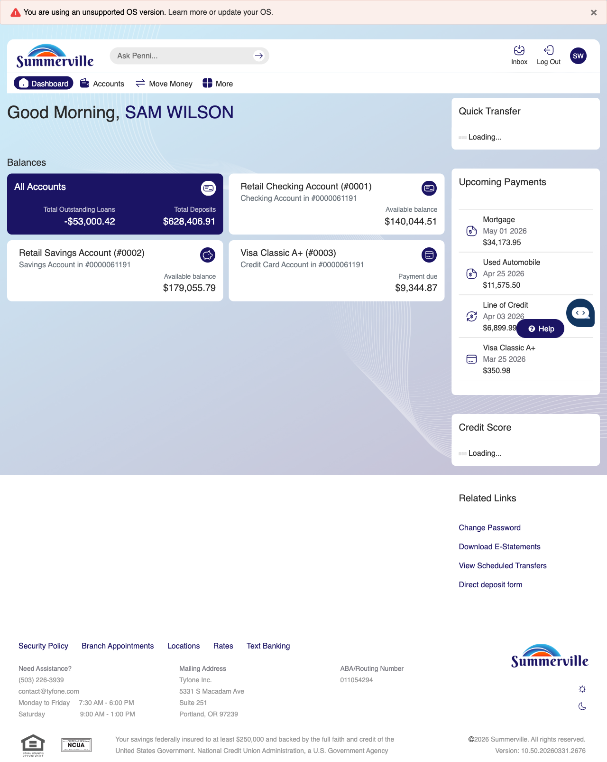
Step 1: Start from Dashboard

Step 2 — Open the More Menu
The member clicks ‘More’ in the top navigation bar. The More options panel expands to show additional features: Check Deposit, User ID and Password, eDocuments, Account Alerts, General Alerts, Password, Forms, One-Time Passcode, Skip A Pay, Do-Not-Disturb, Manage Devices, My Insights, Alert Settings, Recent Activities, and Card Services.
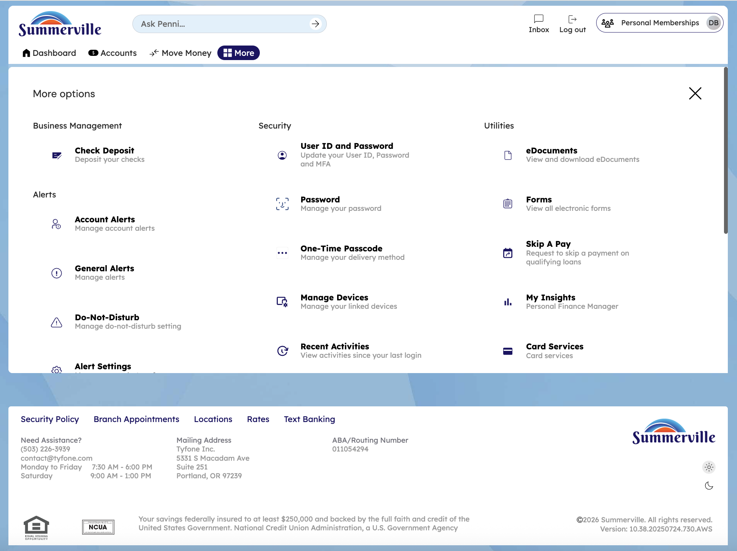
Step 2: More Menu

Step 3 — Navigate from Dashboard to Membership Settings
The Accounts and Memberships page is displayed with a checkbox option for adding an existing membership to digital banking.
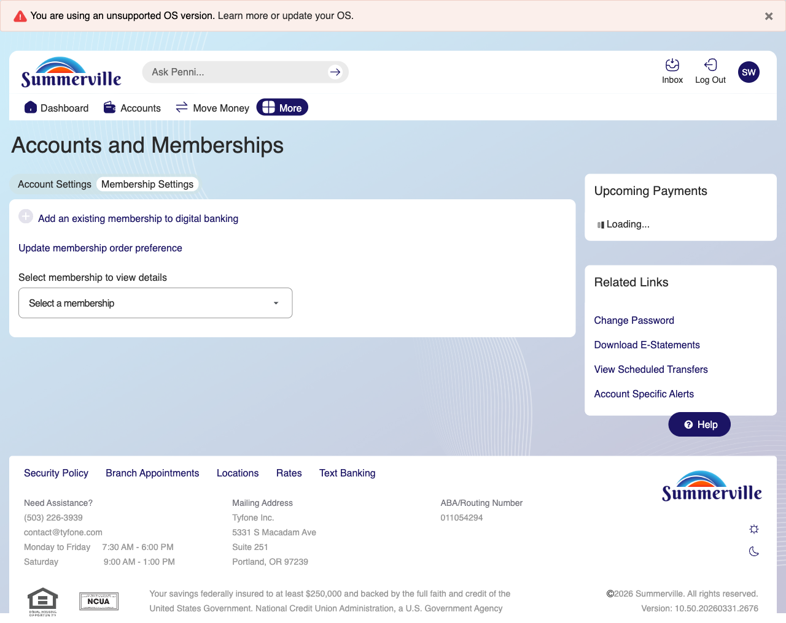
Step 3: Navigate from Dashboard to Membership Settings

Step 4 — View Account Settings
The 'Add an existing membership to digital banking' page is shown with input fields for entering the membership number and details.
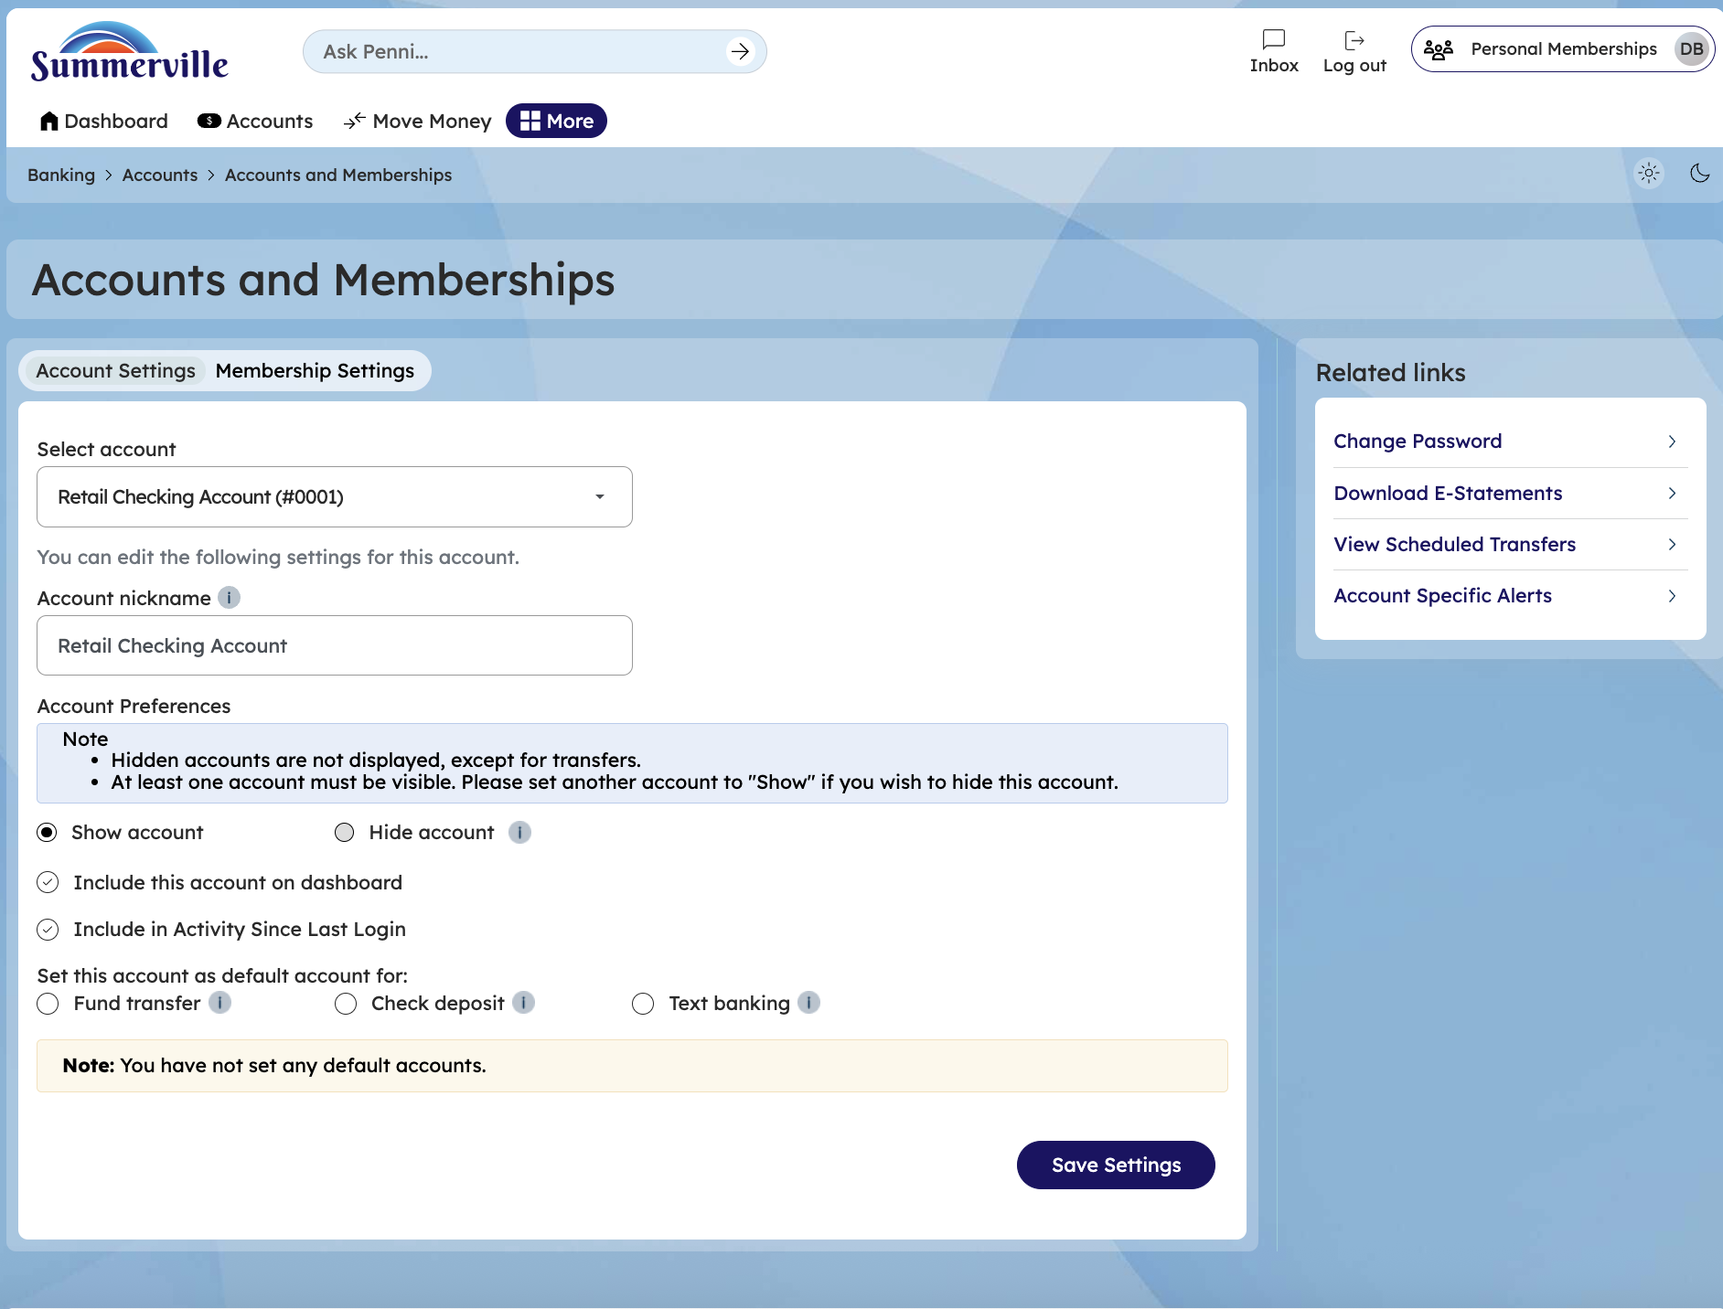
Step 4: View Account Settings

Step 5 — View Membership Settings/Delete a Membership
The 'Add an existing membership' page displays the Membership number field and a Quick Transfer section with account selection dropdowns for configuring transfer preference,you can also delete a membership by clicking on delete membership option.
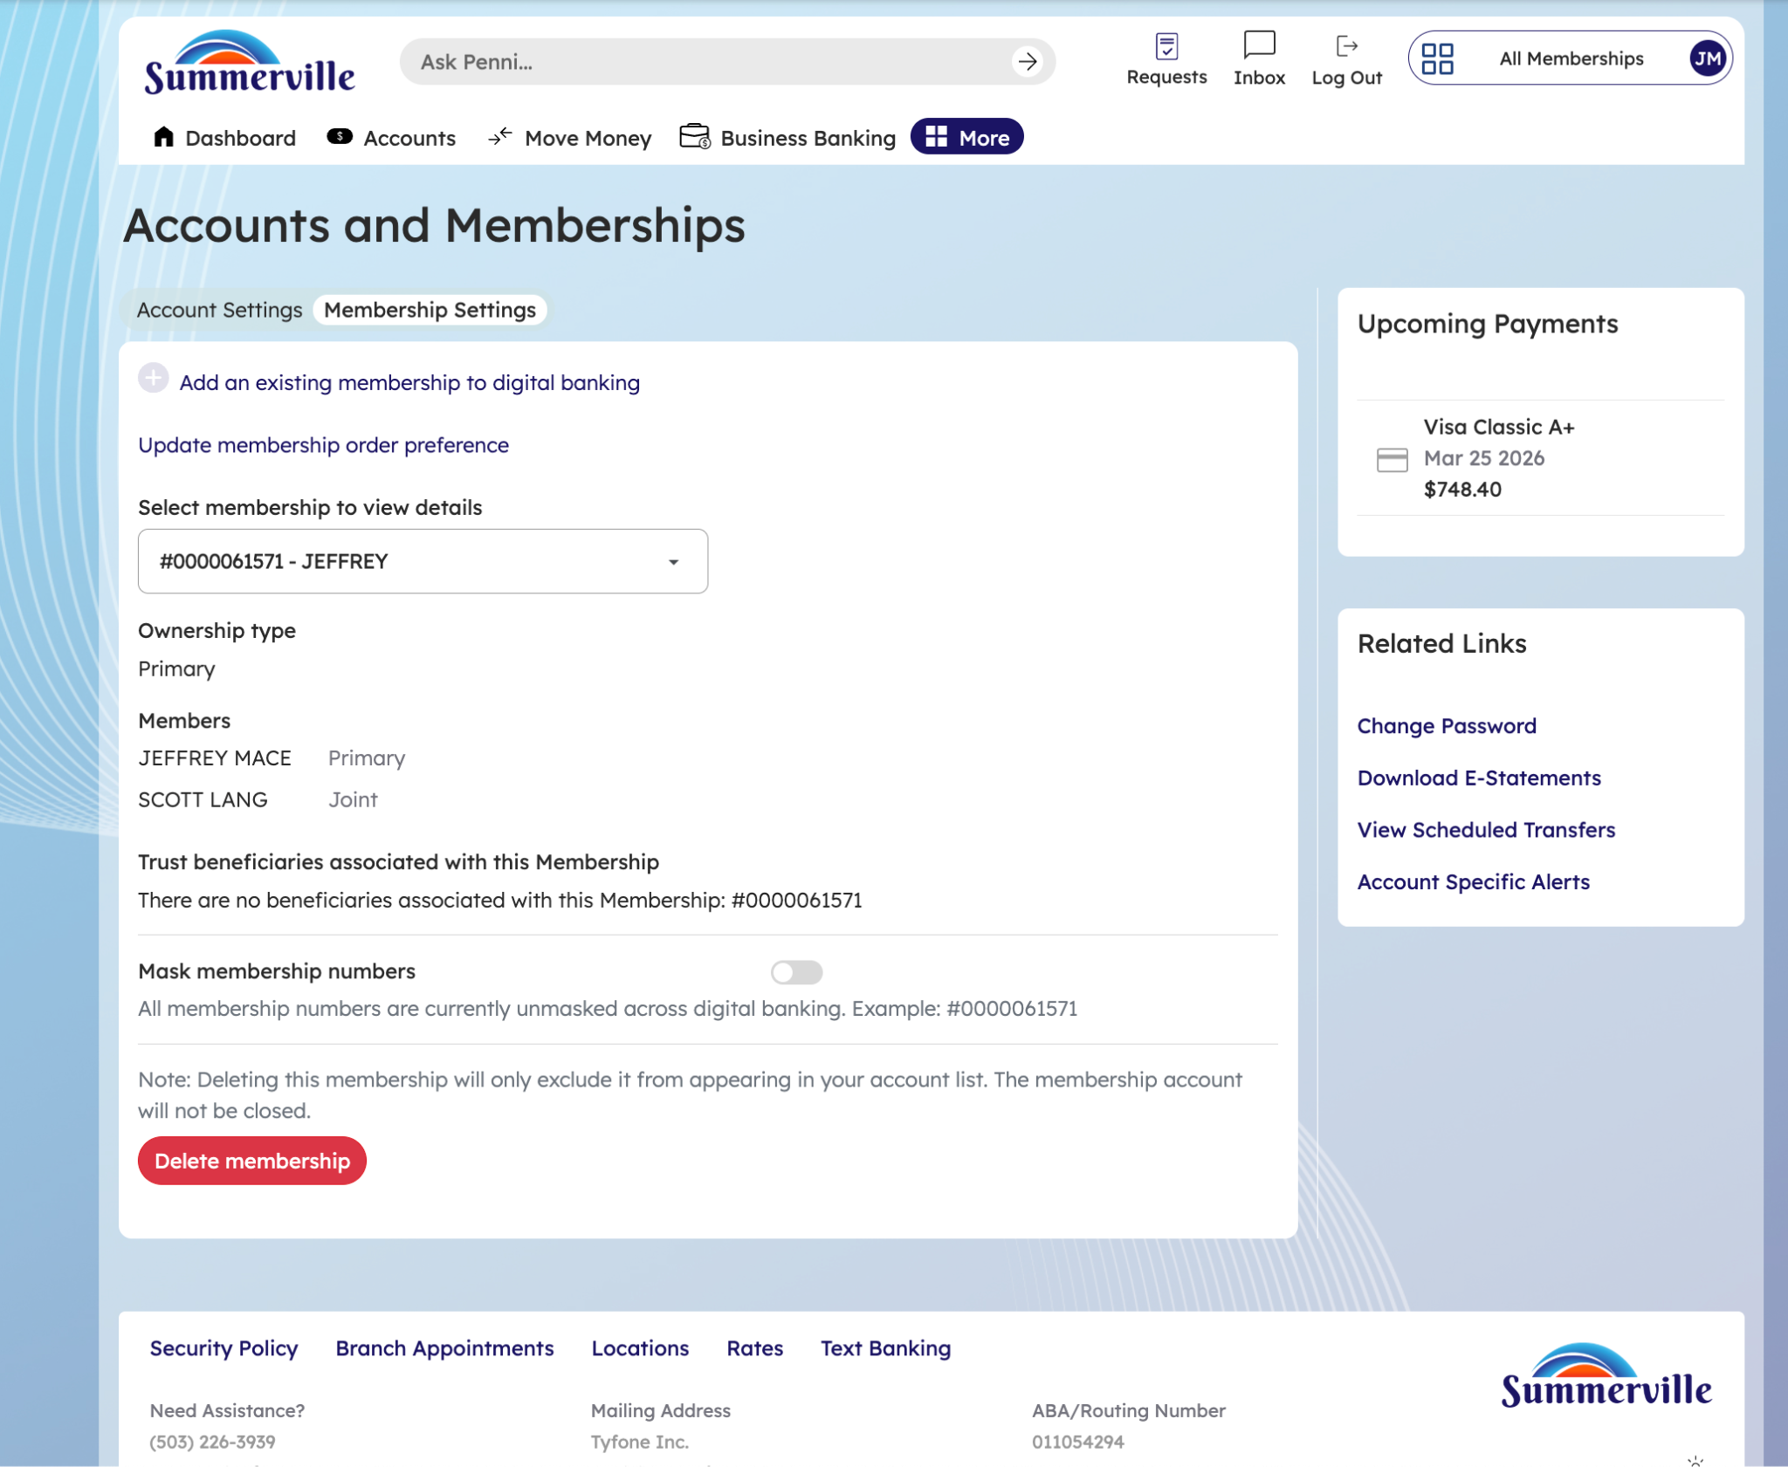
Step 5: Configure Account Display Settings

Step 6 — Switch Active Membership via Profile
The Profile selection modal is displayed for user Donald Blake, showing the Preferred profile option and Personal Memberships group with two associated business accounts listed.
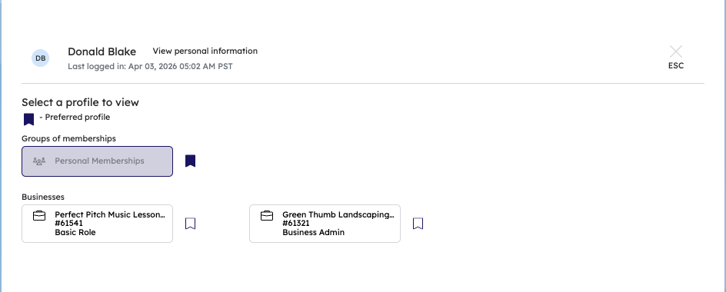
Step 6: Switch Active Membership via Profile

